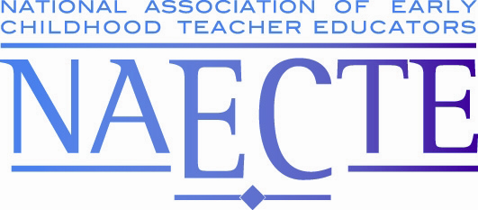

NAECTE 2022 AWARDS
November 16, 2022

Outstanding Early Childhood Teacher Educator Award | Outstanding Dissertation Award
Pamela Evanshen, Ed.D.  East Tennessee State University  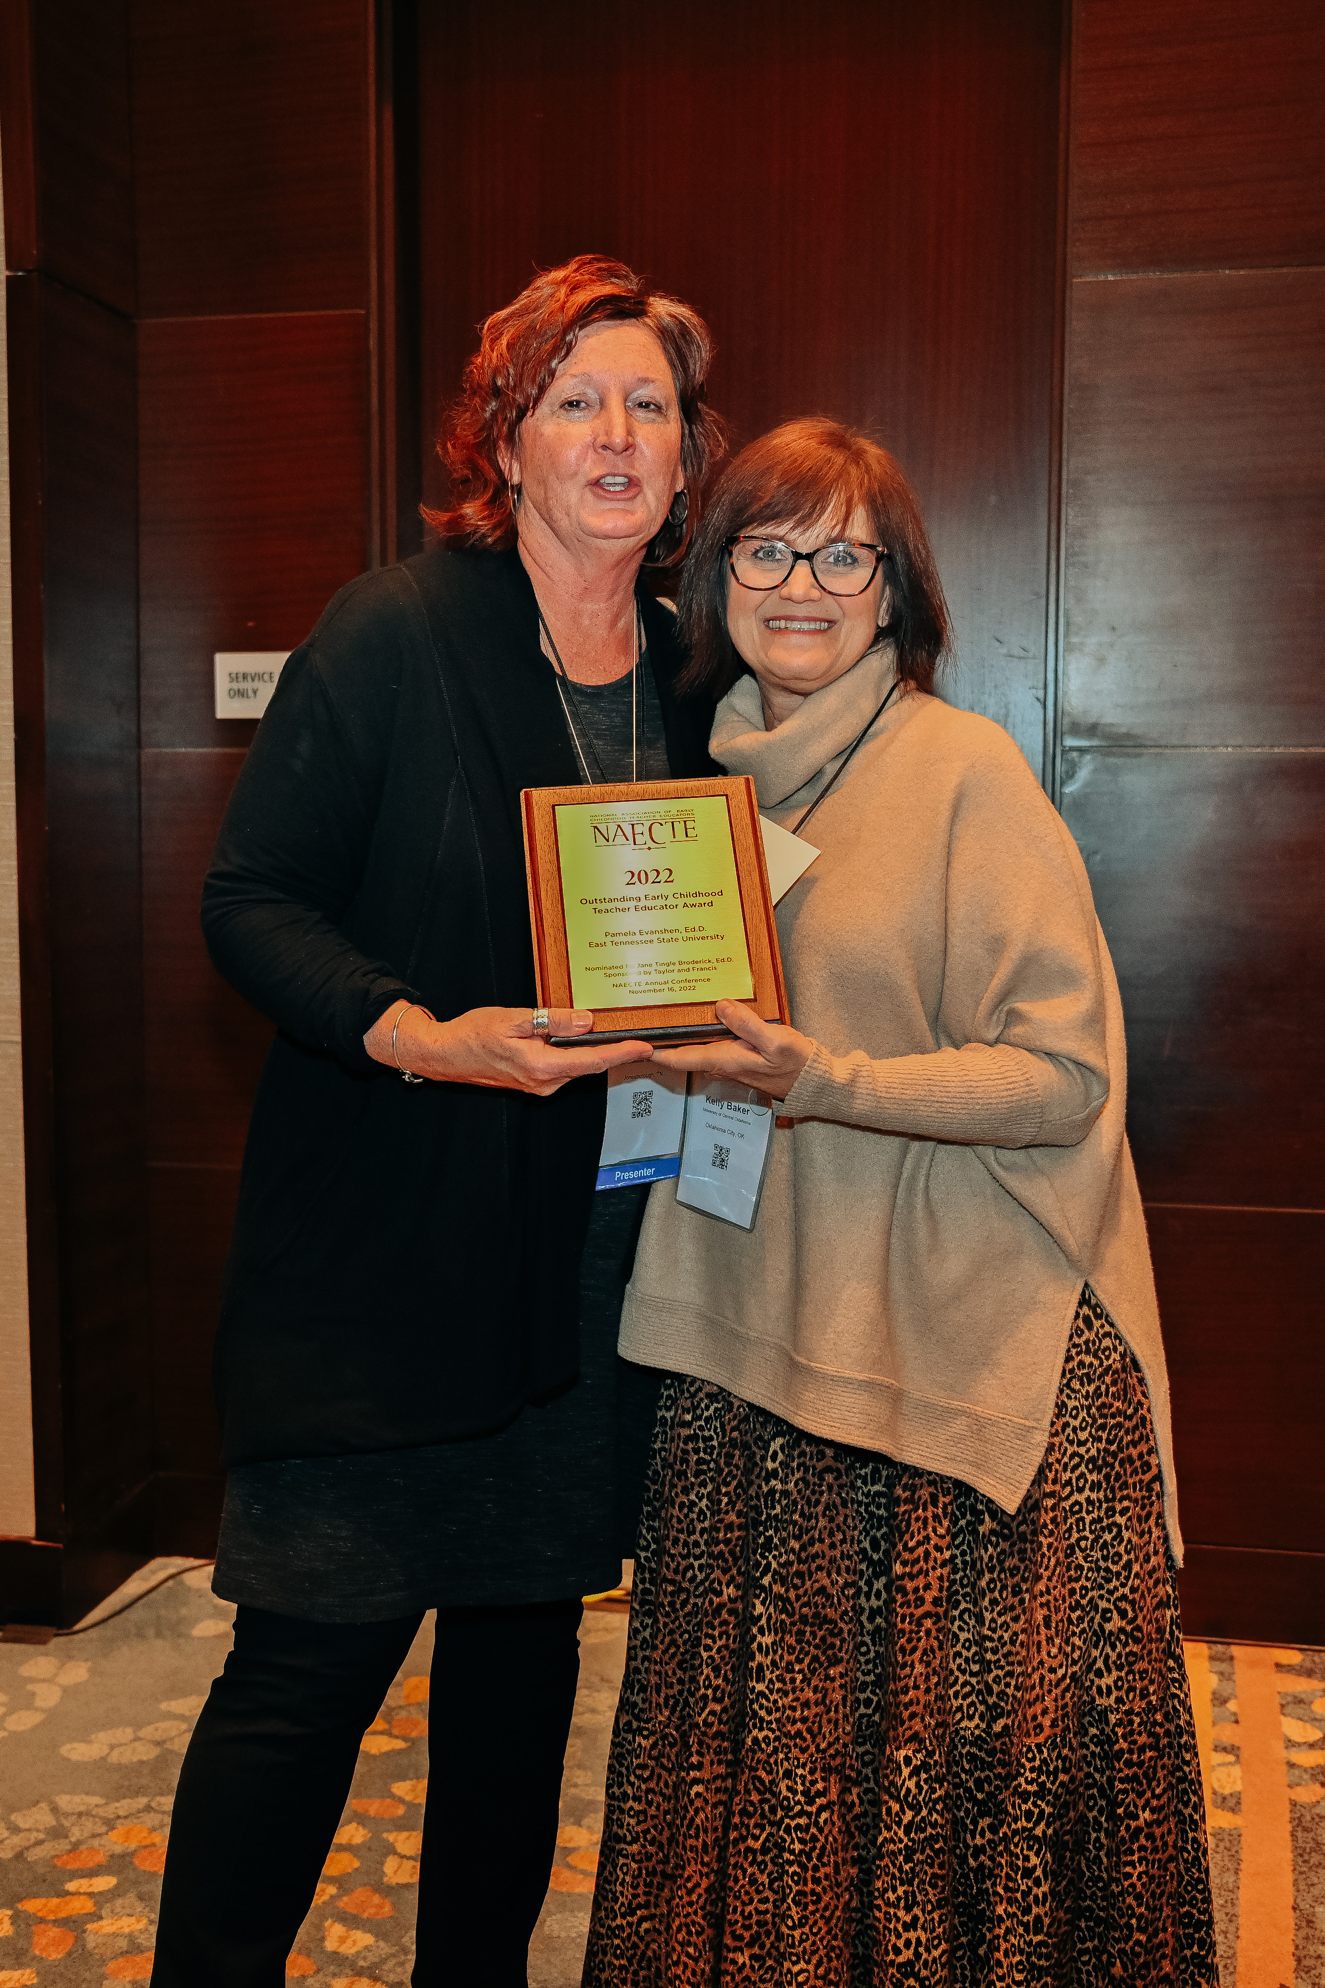  Nominated by Jane Tingle Broderick, Ed. D.  Sponsored by Taylor & Francis | David Barry, Ph.D.  West Chester University of Pennsylvania  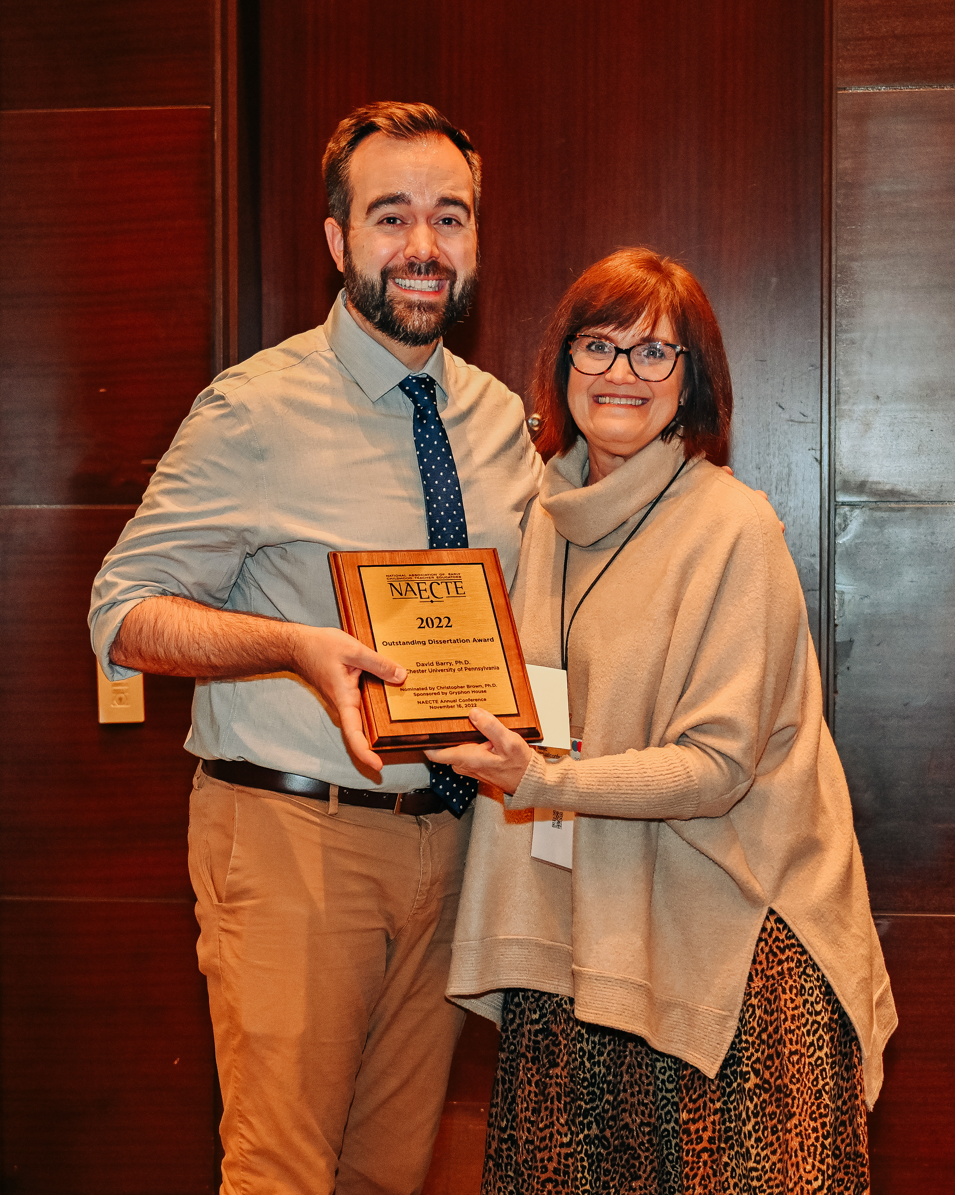  Nominated by Christopher Brown, Ph.D.  Sponsored by Gryphon House
Early Career Research Grant | Established Career Research Grant
Narges Sareh, Ph.D.  Northwest Missouri State University  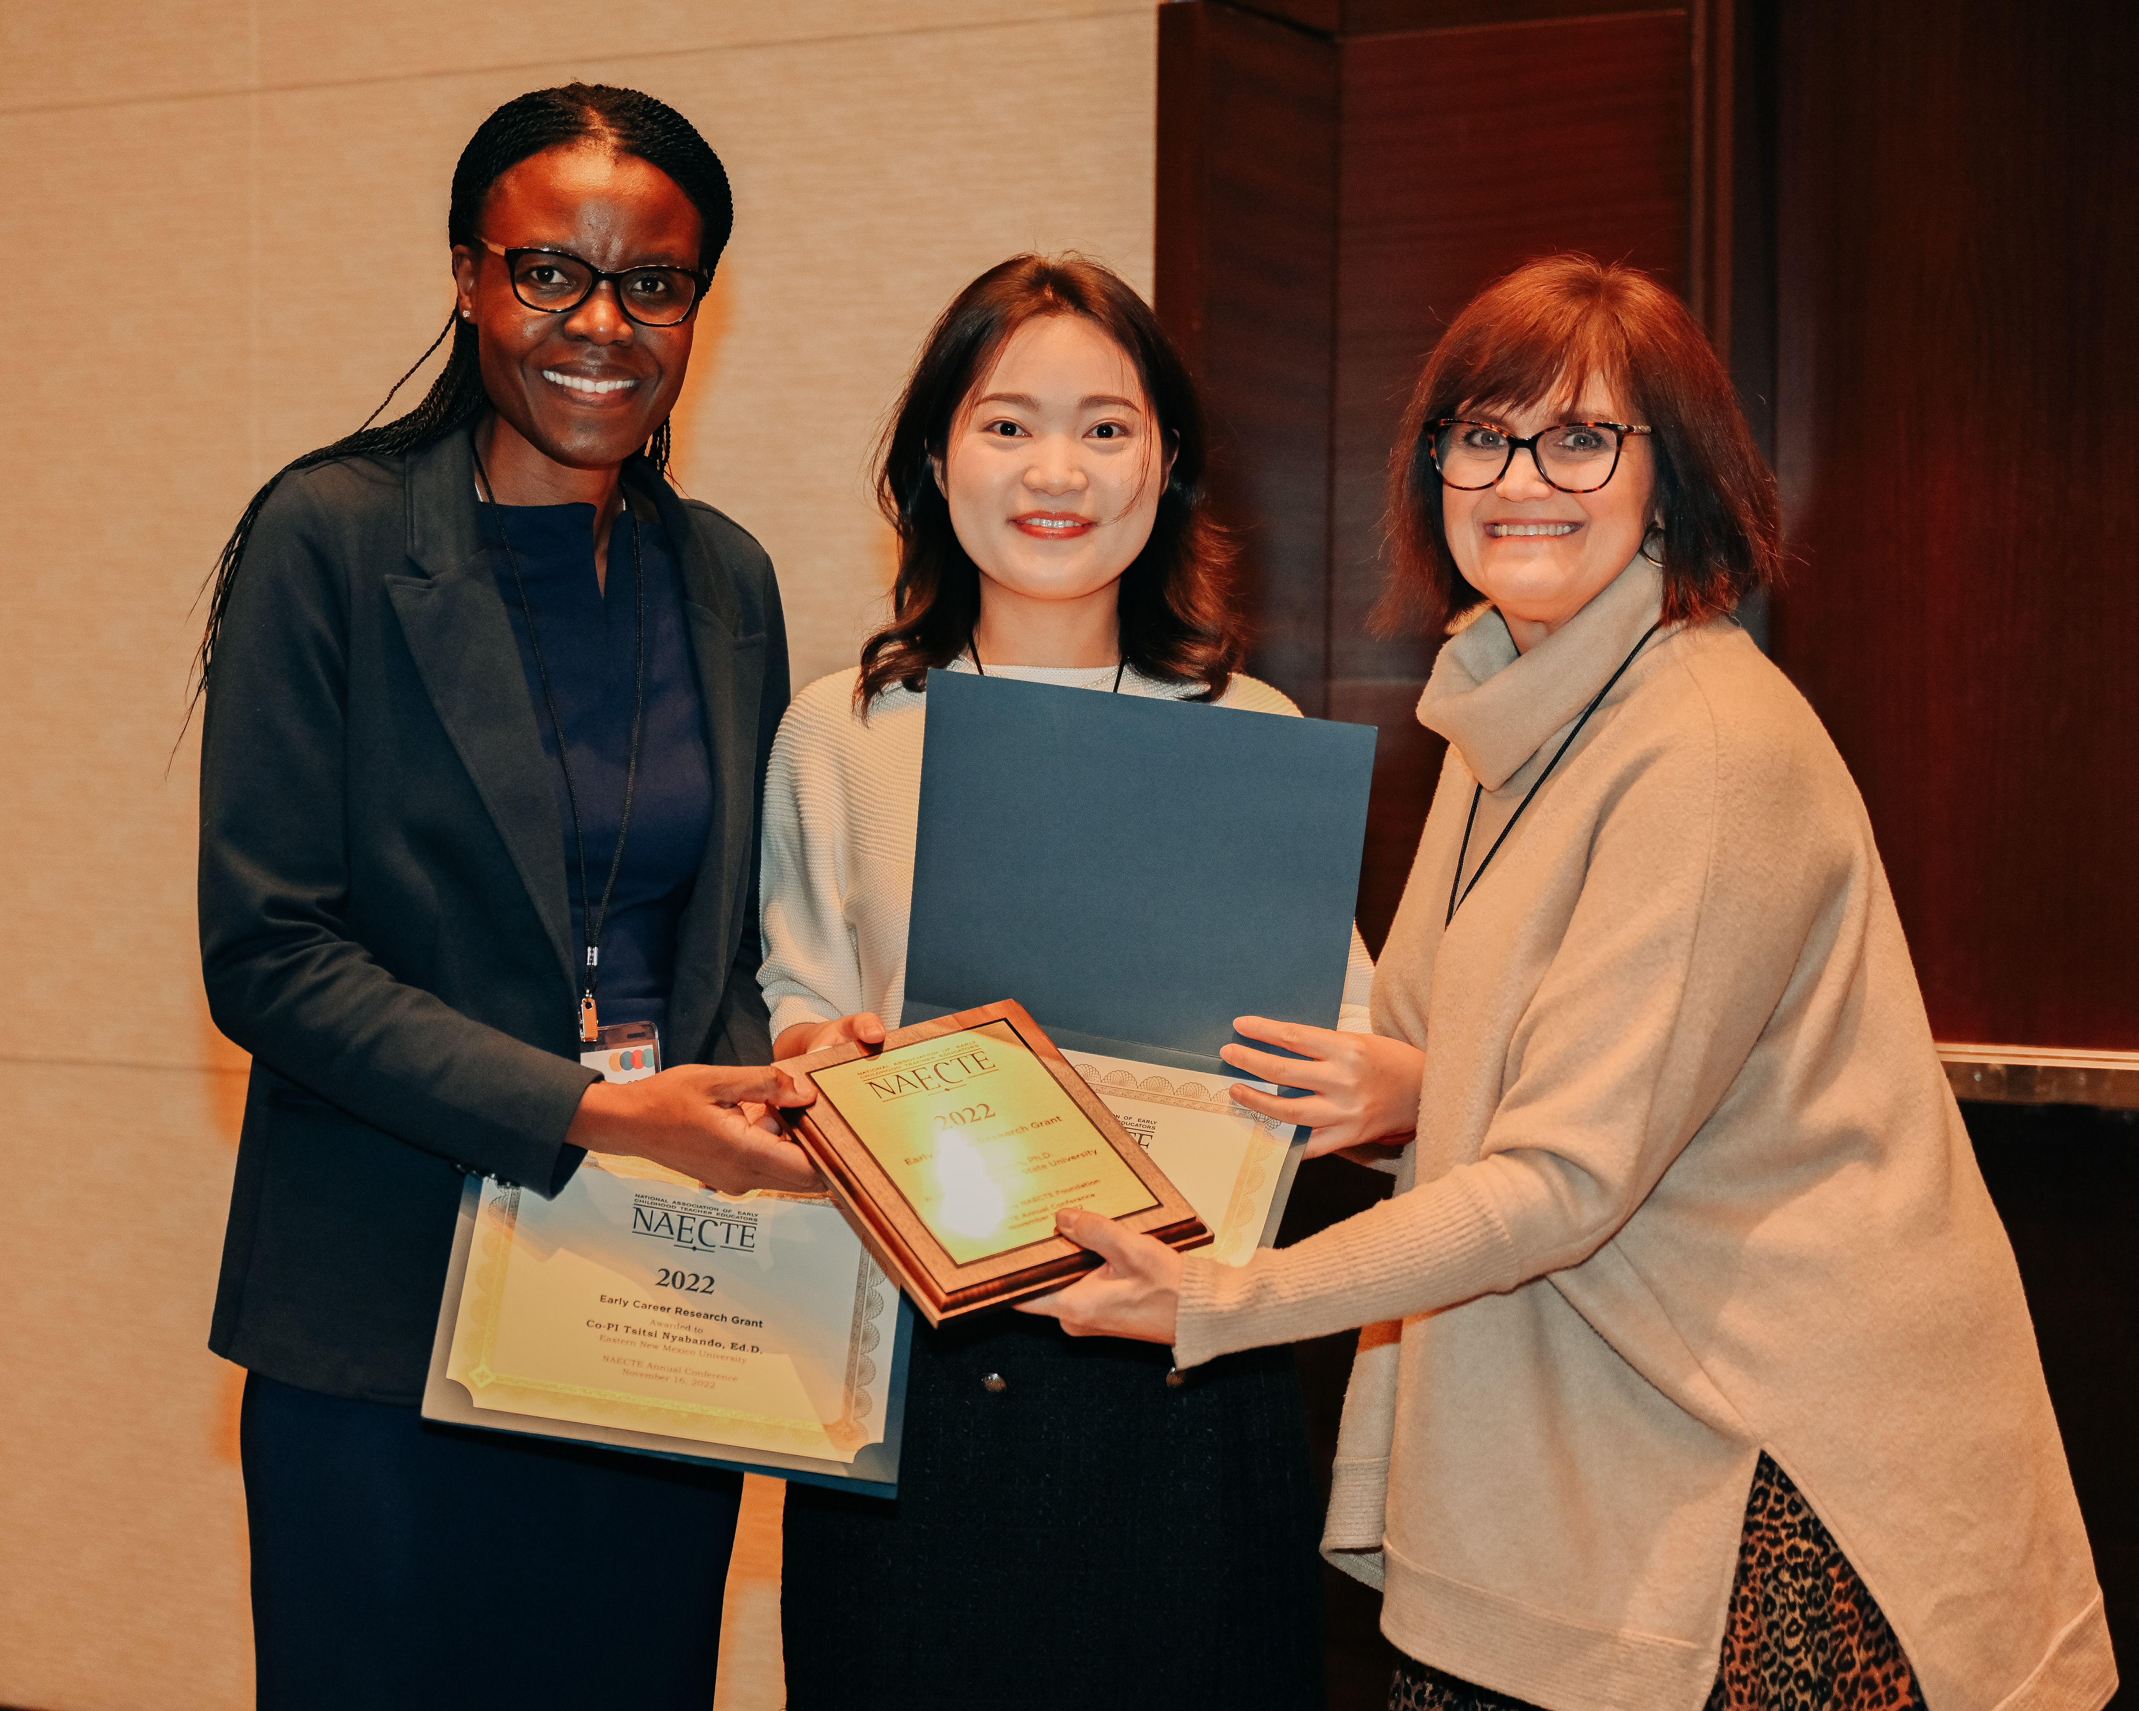  Sponsored by NAECTE Foundation | Allison Wilson, Ph.D.  University of Montana  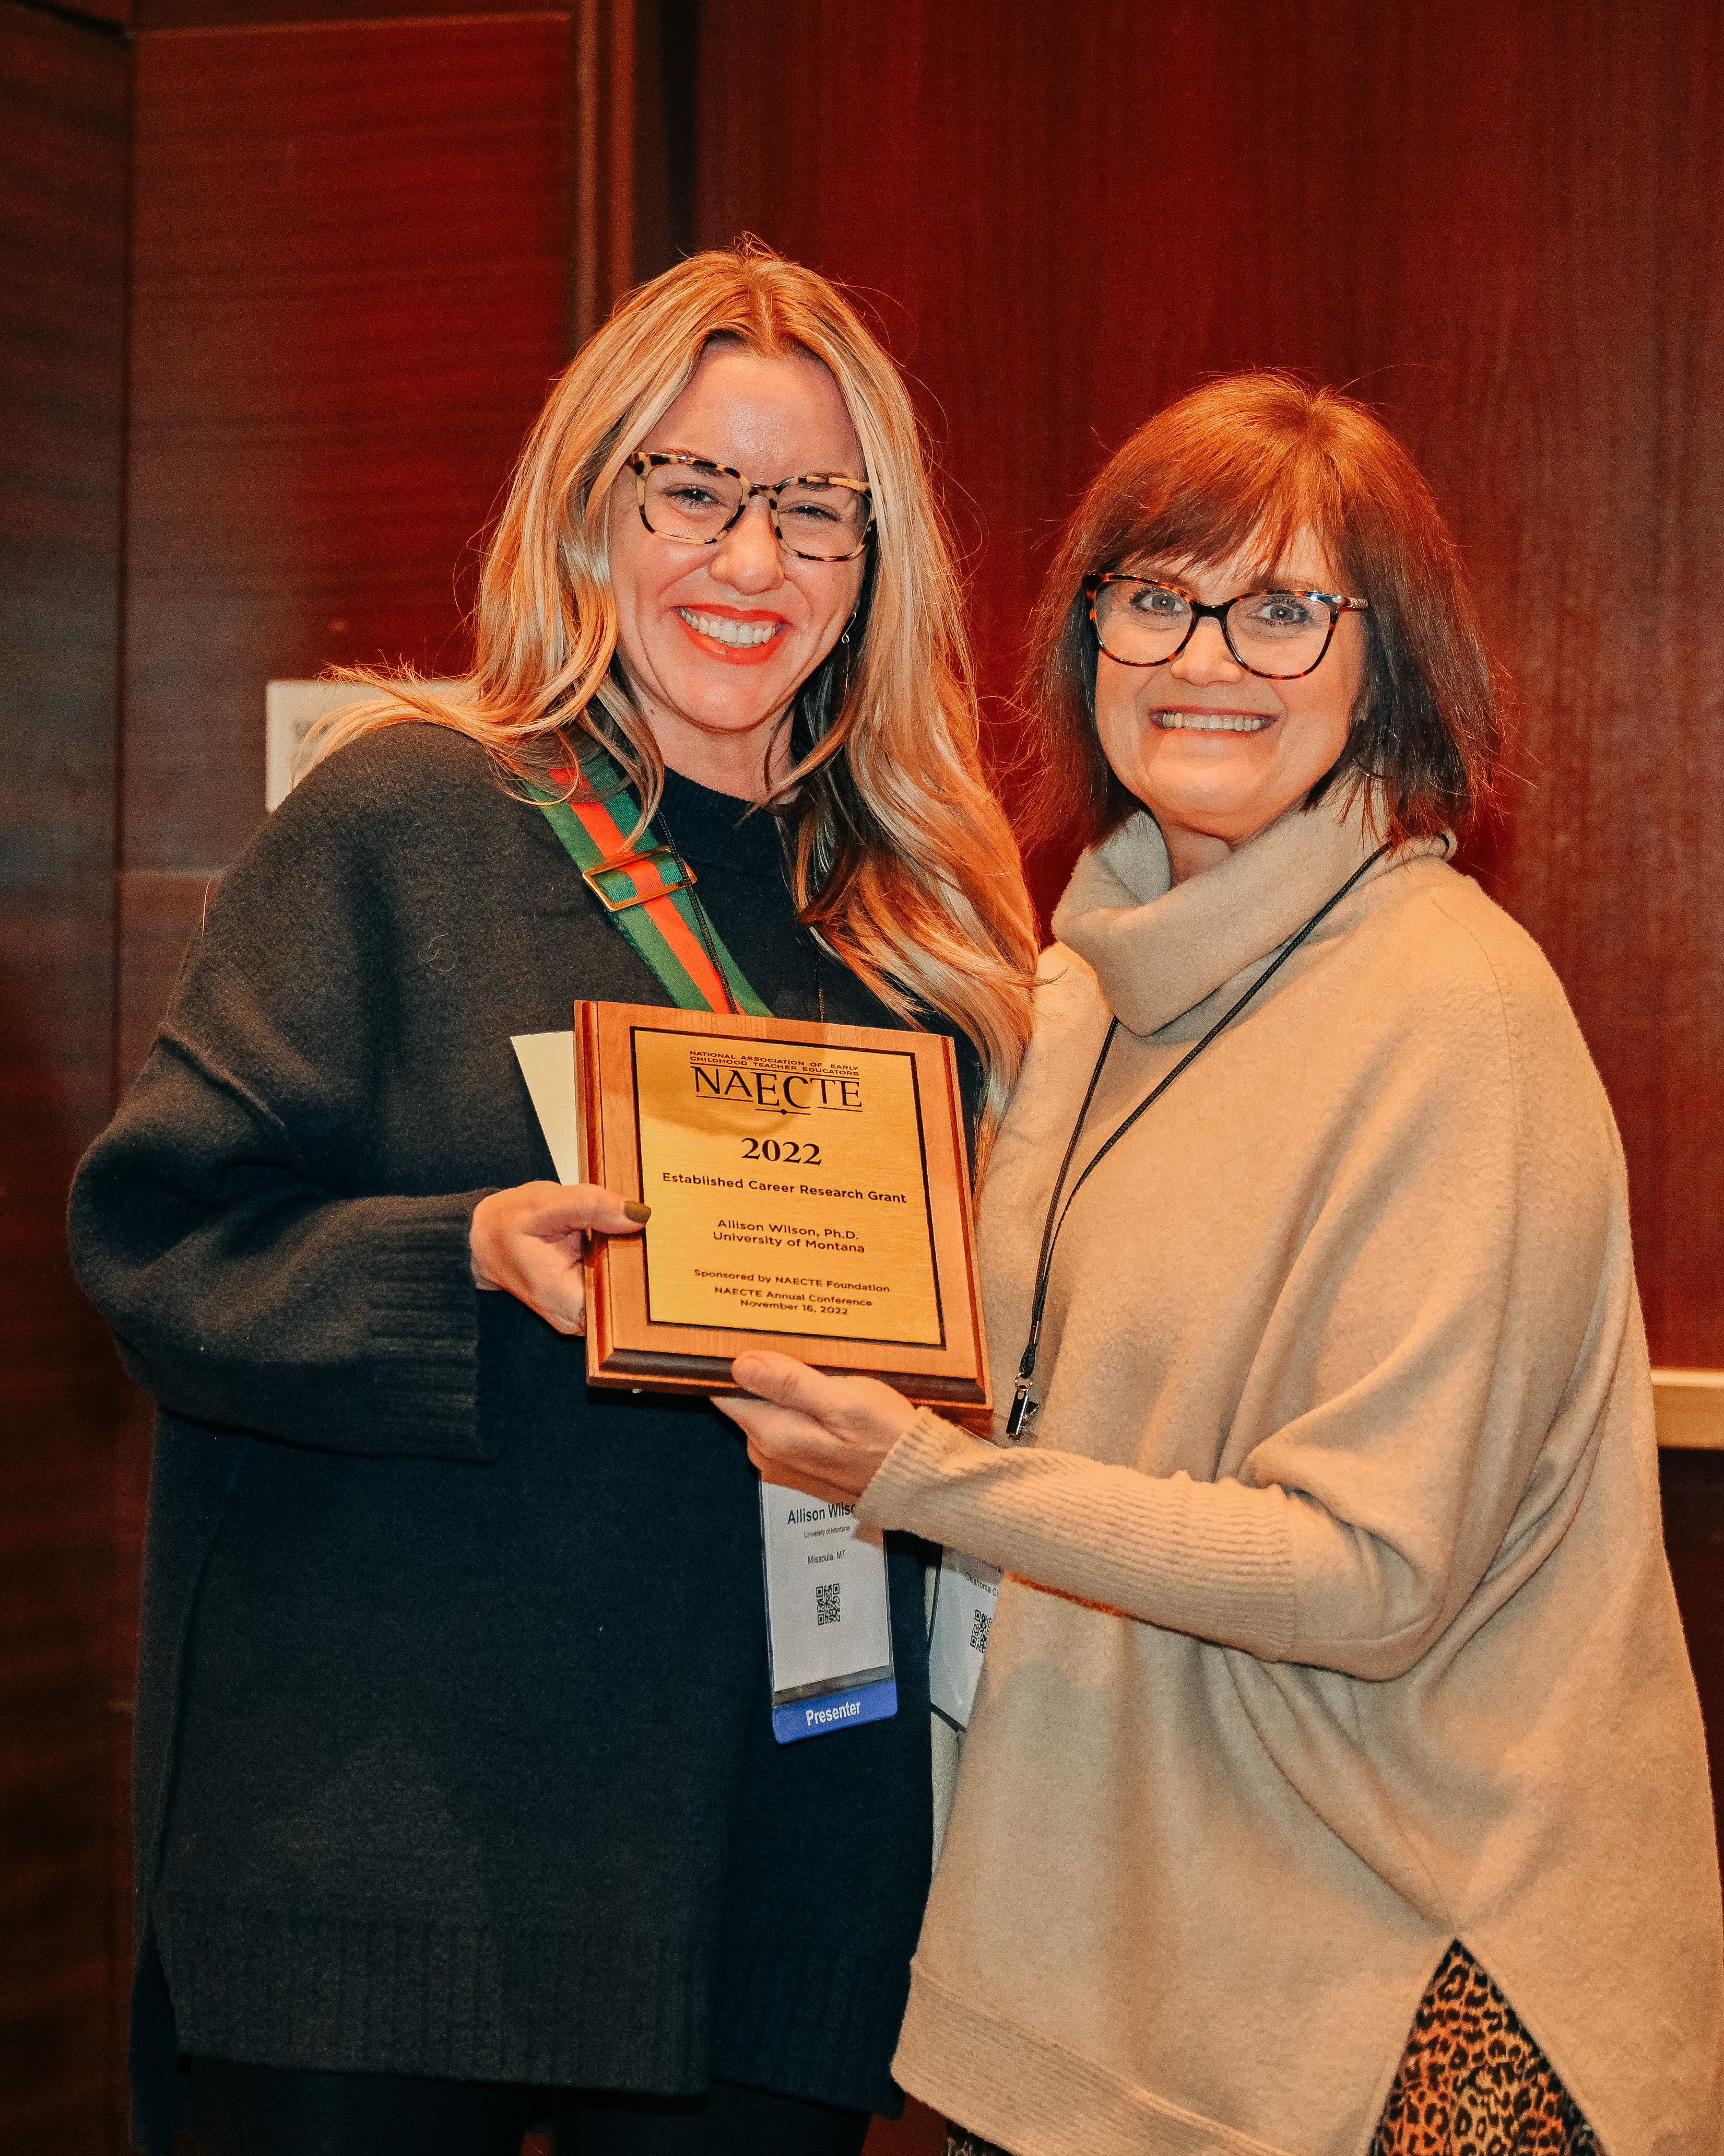  Sponsored by NAECTE Foundation
Doctoral Scholarship | Student Travel Grants
Katherine Madison, Ed.D. Candidate  East Tennessee State University  Sponsored by NAECTE Foundation | Chelsea McClure, Towson University  Olufunke Olaleye, Widener University  Kehinde Helen Orimaye, East Tennessee  State University  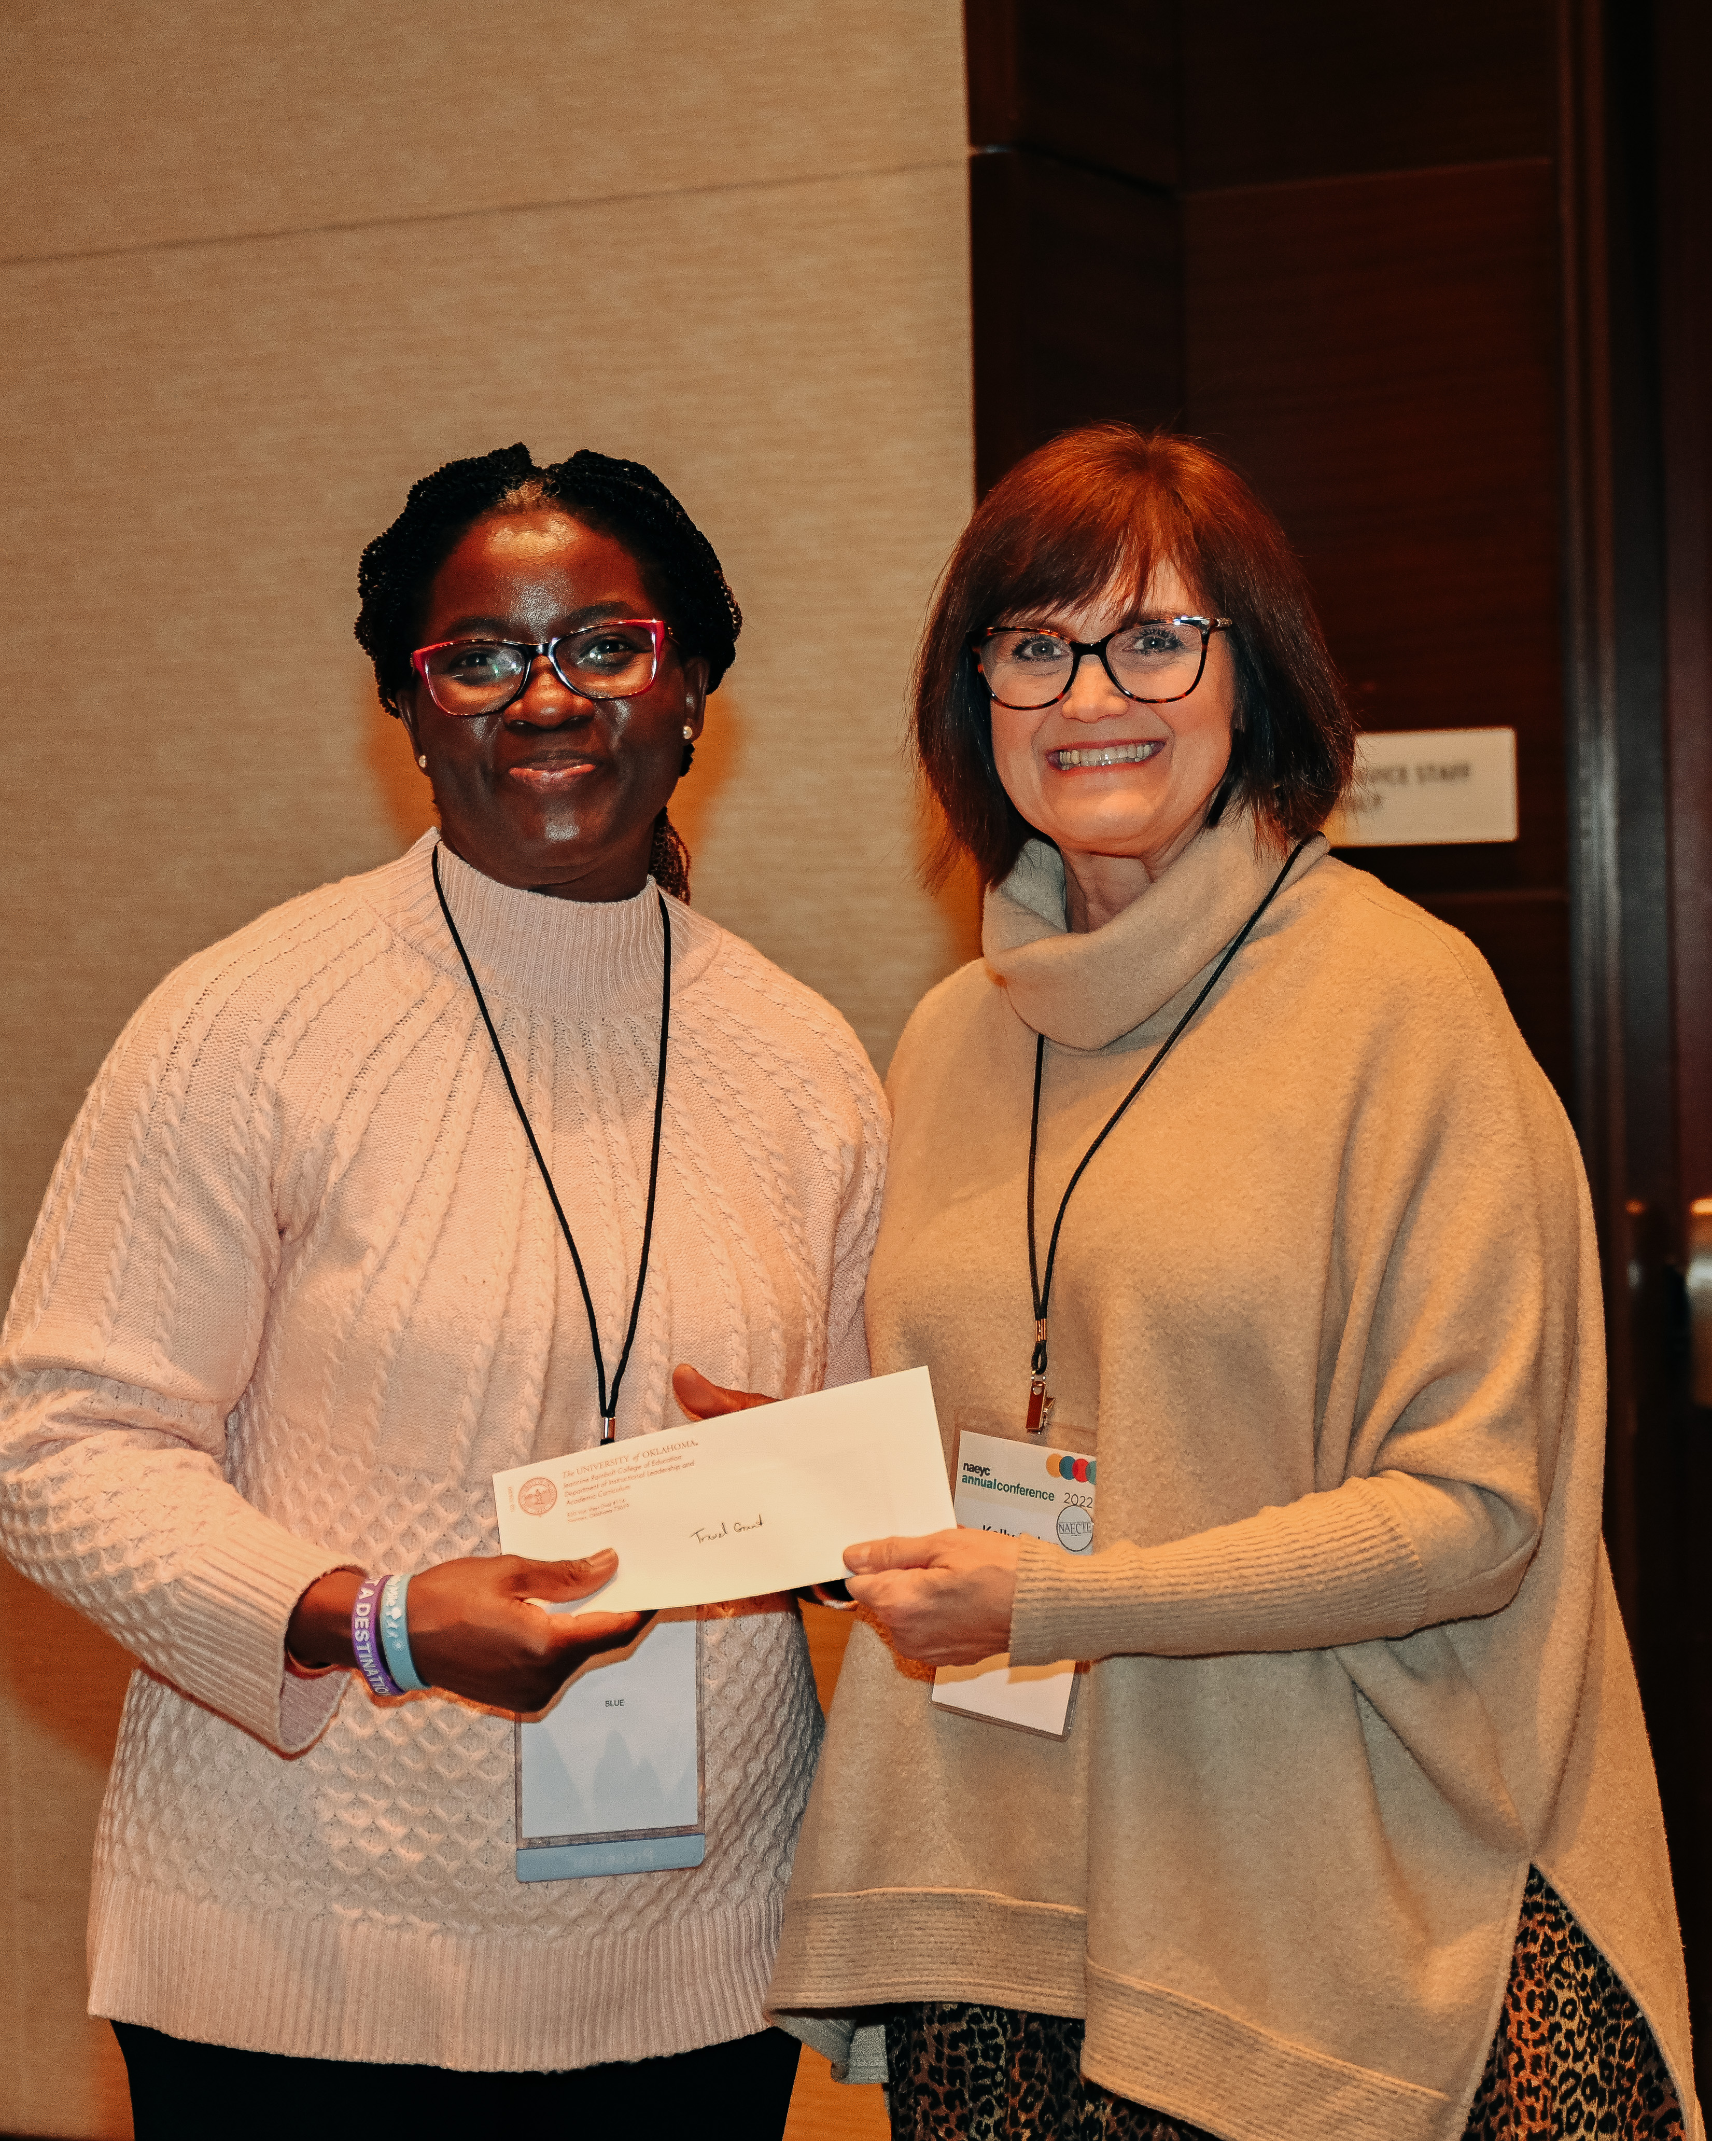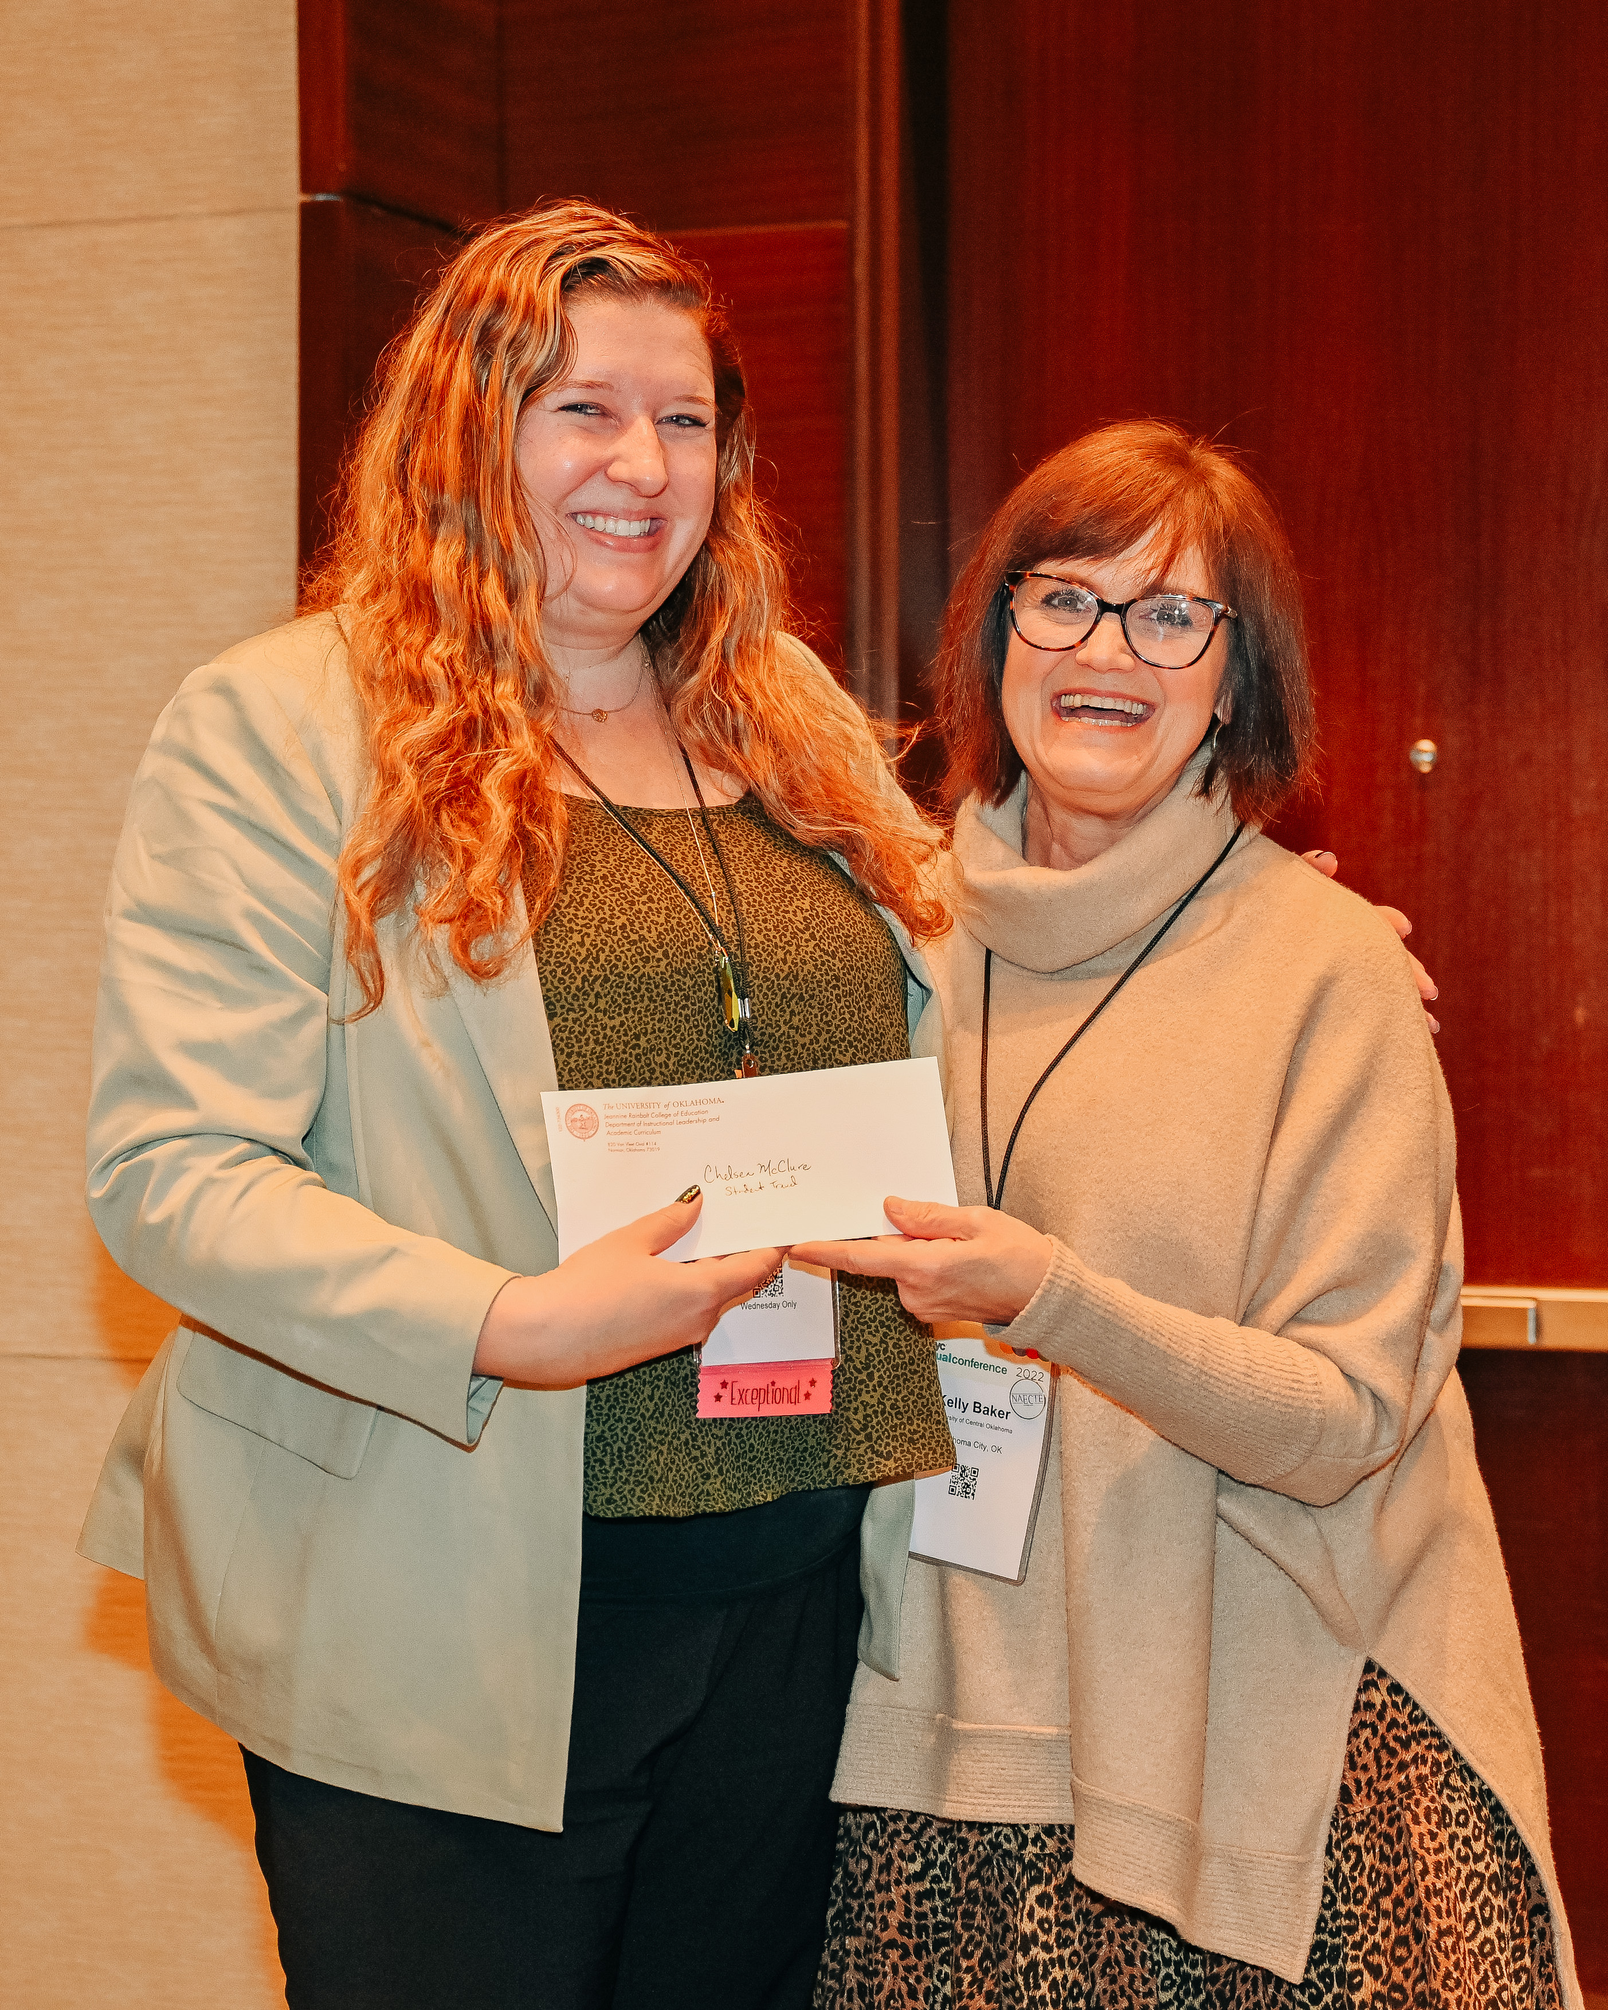  Sponsored by Taylor & Francis and  NAECTE Foundation
Journal of Early Childhood Teacher Education
Outstanding Journal Article of the Year Award
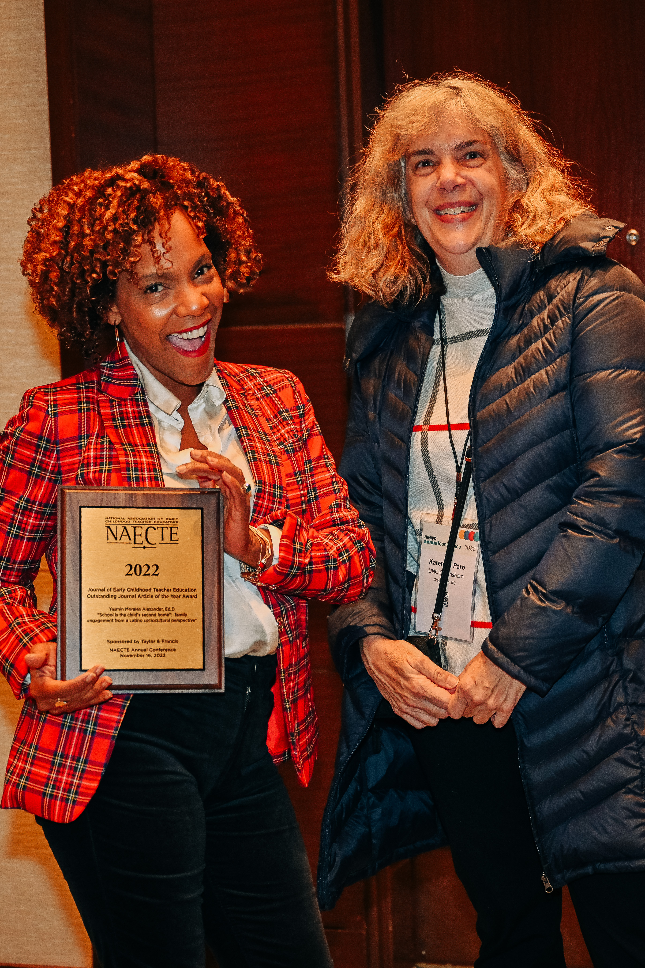

“School is the child’s second home”: Family engagement from a Latino sociocultural perspective”
Yasmin Morales Alexander, Ed.D.

Sponsored by Taylor & Francis

Thank you!

A special thank you to Reagan Rodriguez with Taylor & Francis, and Jennifer Lewis with Gryphon House for coordinating with the publishers to sponsor the awards and honoraria for the distinguished recipients.

Thank you to the award committee members and reviewers for their time and commitment to the selection process: Amber Beisly, Erin Casey, Jennifer Chen, Lea Ann Christenson, E. K. Cho, Jeanne Galbraith, Melissa Jozwiak, and Zeynep Isik-Ercan.

NAECTE Grants and Awards:
Please consider submitting nominations/applications for the following 2023 NAECTE Grants and Awards:

NAECTE Foundation 2023 Summer Research Grants (new this year):
• Doctoral Student Research Grant
• Early Childhood Teacher Educator Research Grant
NAECTE Fall 2023 Sponsored Grants and Awards
• Outstanding Early Childhood Teacher Educator
• Outstanding Early Childhood Practitioner
• Outstanding Dissertation
• Student Travel Grants (2)
NAECTE Foundation Fall 2023 Grants and Awards
• Doctoral Scholarship
• Advocacy Award
• Early Career Research Grant
• Established Career Research Grant
Journal of Early Childhood Teacher Education 2023 Award
• Outstanding Journal Article of the Year Award
See http://naecte.org/about/naecte-foundation/ for award criteria and nominating instructions. Inquiries regarding awards and nominations can be directed to Kelly Baker and Jennifer Chen at kbaker12@uco.edu and jchen@kean.edu.

The Awards Ceremony program was prepared by
NAECTE Foundation President, Dr. Kelly Baker & Secretary, Dr. Eun Kyeong Cho.

